Program the ASL165 HHP/Display device.

Start the SEGGER J-Flash V7.96j application program on the PC. The following screen should be displayed.

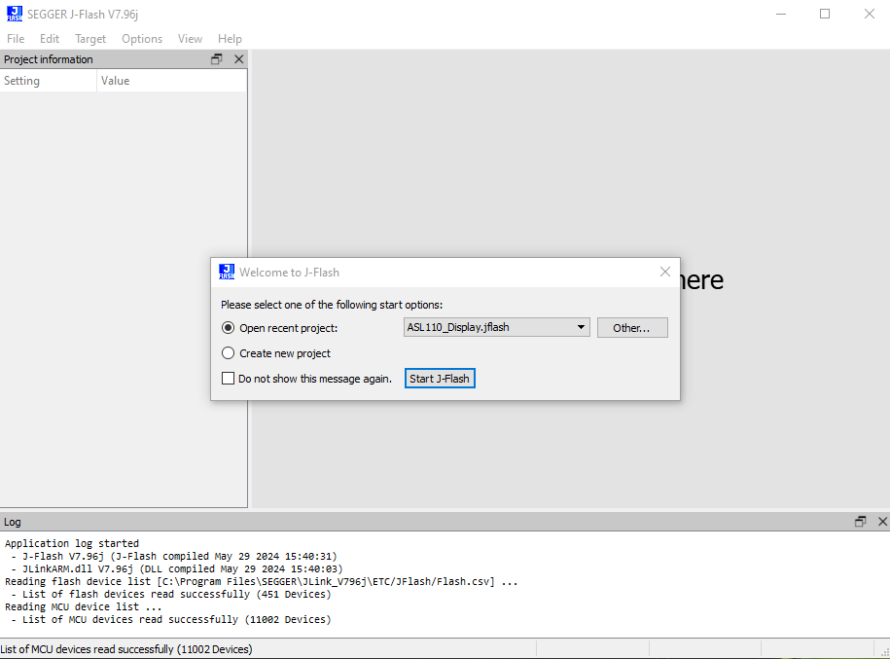

In the above screen shot, the Open Recent Project is filled with ASL110_Display.jflash. If your box does have the ASL110_Display.jflash file displayed press “Other…” and a file selection is displayed. Locate the ASL110_Display.jflash file and select “Open”. See the screen shot on the next page.

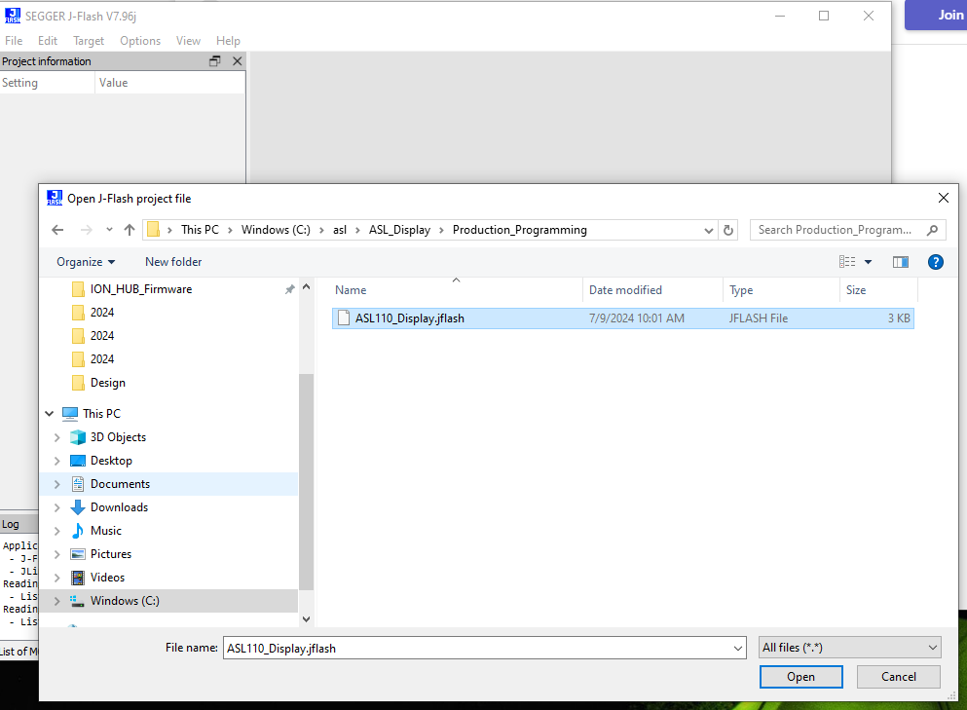

Next open the Firmware file, by selecting FILE->Open Data File as shown below.

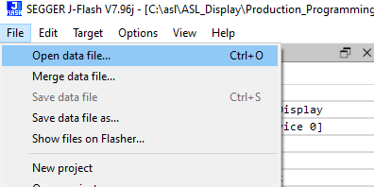

If you open the correct file, the screen should look similar to the following.

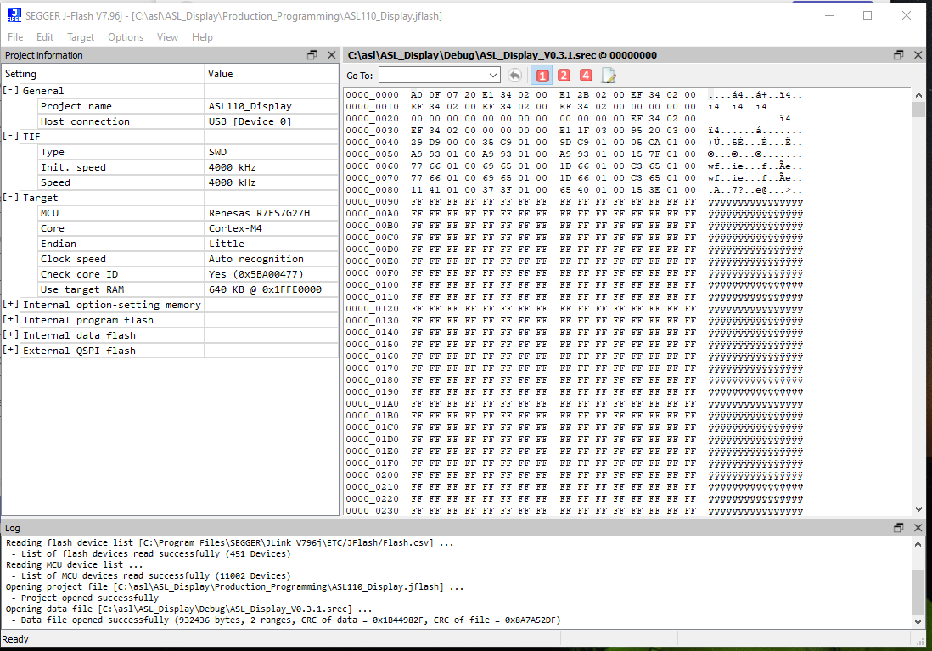

To program the ASL165 firmware, press F7 or select Target -> Production Programming menu selection.

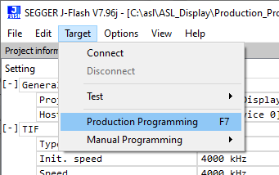

To program the ION HUB open the ION HUB Project File named ASL104E_HUB.jflash.

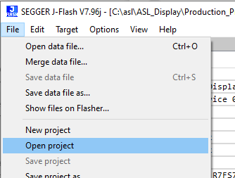

Open the firmware file named, ION_HUB_Firmware_V0.3.1.srec.

If you opened up the correct files, the screen should look like this.

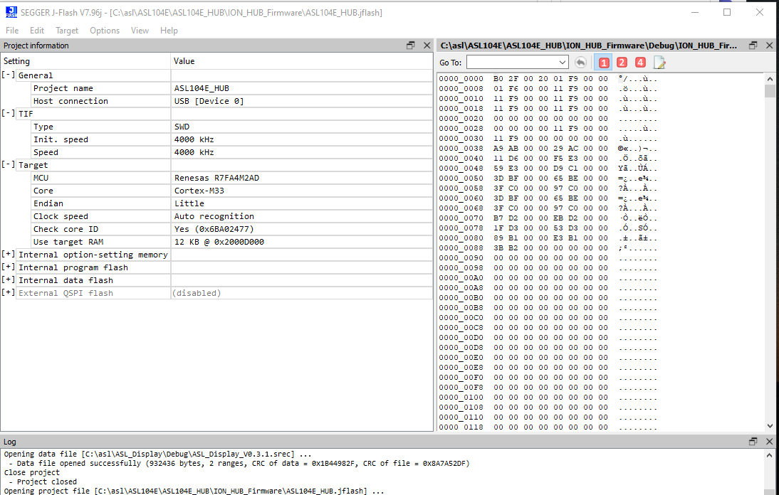

Press F7 to program the ION HUB.

ALL DONE!